MCKV INSTITUTE OF ENGINEERING

Computer Science and Engineering – Data Science

***Name - Abhinaba Sarkar***

***Roll No. - BTECH/CSE-DS/2020/47***

**Assignment Number: *7***

Problem statement:

Write a program that accepts a sentence and calculate the number of upper-case letters and lower-case letters.

Input Format: The first line of the input contains a statement.

Output Format: Print the number of upper case and lower case respectively.

Assignment 7.a)

Source code:

s1=input()

up=0

lw=0

for i in s1:

if 65<=ord(i)<=90:

up +=1

if 97<=ord(i)<122:

lw +=1

print(up,lw)

output:

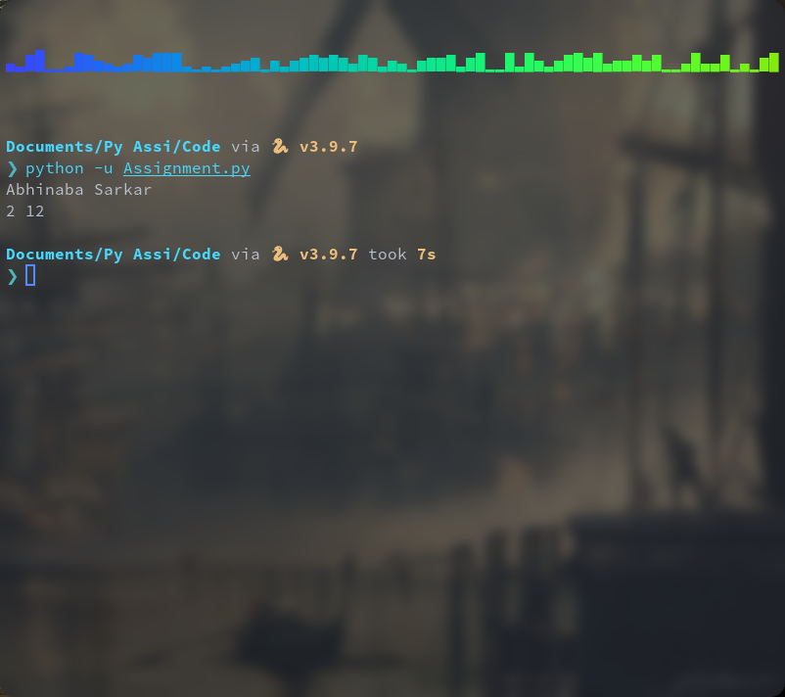

Problem statement:

Write a program to show all the common words between two strings.

Assignment 7.b)

Source code:

s1="Hello World. I am learning Python."

s2="Hello , I am learning C."

l1=s1.split()

l2=s2.split()

t1=set(l1)

t2=set(l2)

t3=t1.intersection(t2)

print(t3)

output:

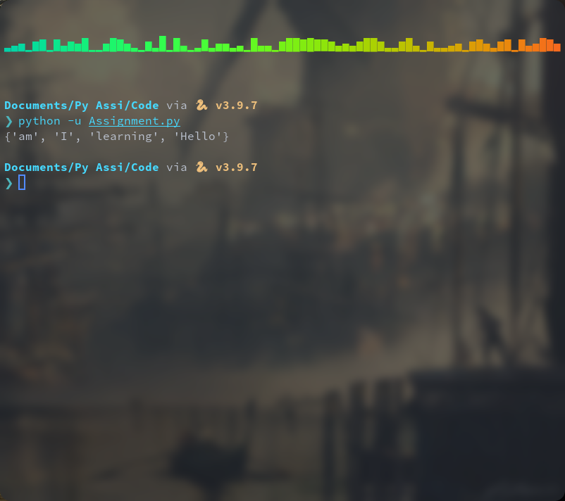

Problem statement:

Write a program that accepts a comma-separated sequence of words as input and prints the words in a comma-separated sequence after sorting them alphabetically.

Input Format: The first line of input contains words separated by the comma.

Output Format: Print the sorted words separated by the comma.

Assignment 7.c)

Source code:

s1=input("Enter a comma-separated word: ")

l1=s1.split(',')

l1.sort()

print(l1)

output:

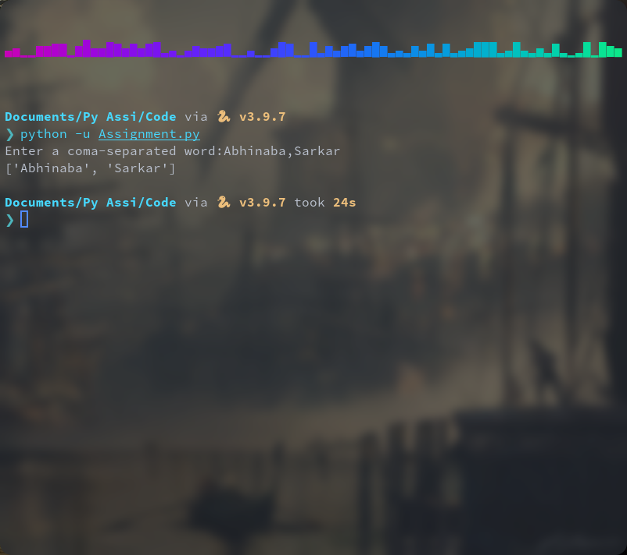

Problem statement:

If we have some email addresses in the "username@companyname.com" format, please write program to print the company name of a given email address. Both usernames and company names are composed of letters only.

Input Format: The first line of the input contains an email address.

Output Format: Print the company name in single line.

Assignment 7.d)

Source code:

a=input("enter your email:")

b=a.index('@')

c=a.index('.')

i=a[b+1:c]

print(i)

output:

